**Quick User Guide for DR02 with Serial & Pulse output**

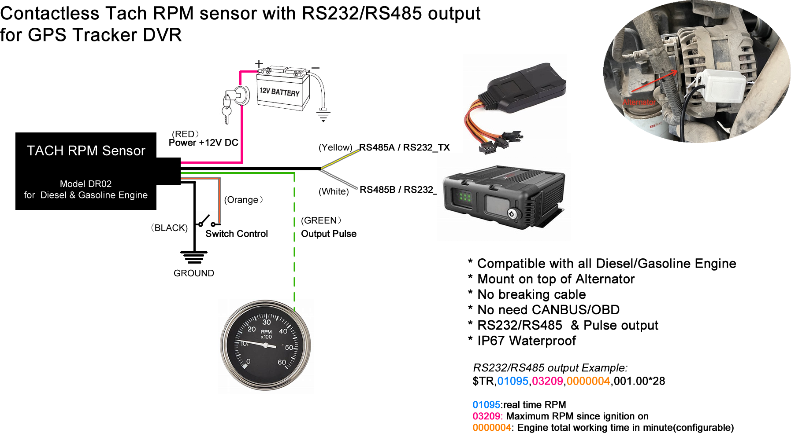

**Model: DR02**

1. **Cable Definition**

RED: Power Supply 12V DC

BLACK: Power GND

**GREEN:** Output Signal (fixed 1pulse/round rpm ratio)

**YELLOW:** RS485A/RS232 TX

**WHITE:** RS485B/RS232 RX

***NOTE: If serial output not work, please switch Yellow & White cable***

1. **Configure Steps:**
2. Connect Switch Cable to enter in setting mode

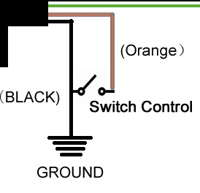

1. Find the vehicle original Alternator, and then mount the DR02 on top of the alternator like below, and fasten the installation:

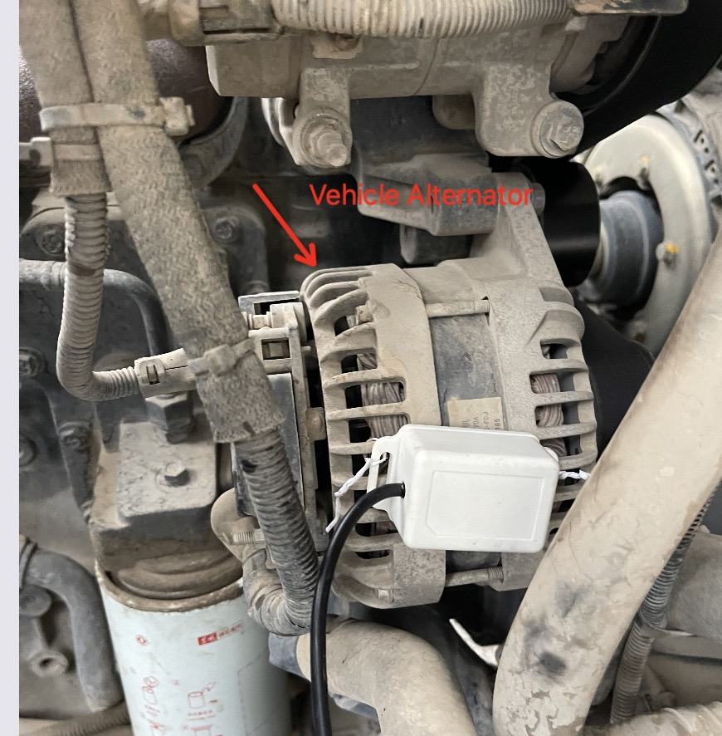 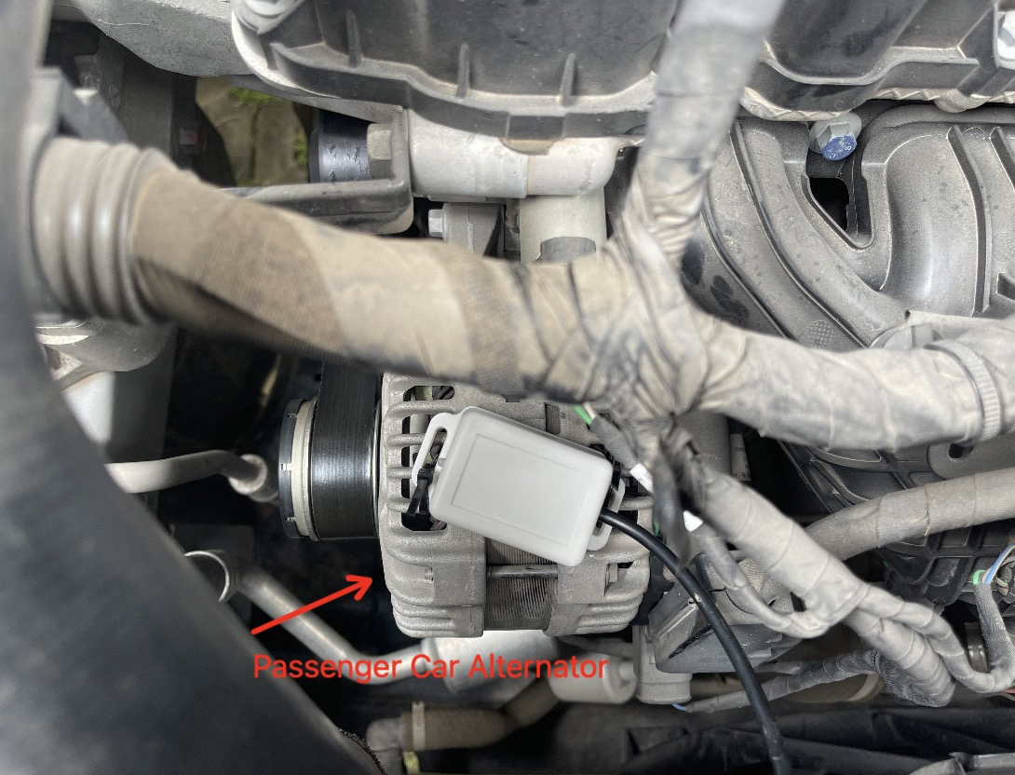

1. Ignition ON the vehicle engine.
2. Power on the Sensor, the LED will stay Green
3. Accelerate the engine to make RPM go to 1000RPM, and keep it at 1000RPM, then Disconnect Switch Cable, the LED will still stay Green and calculate the detected pulse from engine
4. Connect Switch Brown Cable and Disconnect again, the LED will flash
5. The sensor output Pulse signal with fixed Tach RPM ratio 1pulse/round, which means it will output 16.67Hz when 1000RPM.

For example, if the input frequency is 100Hz @1000RPM, the sensor will convert the signal and then output 16.67Hz @1000RPM

1. How to configure Tachometer?

Please set your Tachometer/RPM Gauge tach RPM ratio to 1 pulse/round, then the Gauge will work properly.

1. **RS232/485 protocol: Baud Rate 9600**

Example :

***$TR,01095,03209,0000004,001.00*28***

|  |  |
| --- | --- |
| Content | Description |
| $TR | Head, fixed value |
| 01095 | Real Time Engine speed, unit: RPM |
| 03309 | Maximum Engine speed since ignition on,unit:RPM |
| 0000004 | Total Engine Working Time, unit:minute |
| 001.00 | RPM ratio, 1pulse /round, fixed value |
| 28 | BCC checksum of all data between $ and * |

Command to configure Engine working time:

1. Command to set working time to be 1200 minutes:

$TR,set,hour,0001200*7B

1. Command to reset working time to be 0:

$TR,set,hour,0000000*78